Inspired By:

stellar.com



ABOUT STELLAR

stellar.com

We are happy to introduce ourselves as an extremely customer centric Engineering Company

manufacturing equipment in the eld of Heating, Ventilation, and Air-conditioning. The team at

stellar has been working in the HVAC industry for more than 25 years now, total collective

experience of the core team is more than 100 years. With our technical & young leadership,

design strength & on-site knowledge, we offer products & services that allow our customer to

improve their business.

STELLAR has started with its rst manufacturing unit at Bilimora, Gujarat (India) with 8000

Sq. Ft. covered area & 25 employees, we plan to expand geographically across India for quicker

customer reach.

Bilimora is the town where the history of “ factory made ducting “ started in India & has an

excellent local resource for duct fabrication from senior plant level people to shop oor people to

customer facing people. Also the place offers several associates (vendors, job-workers) who have

been providing products & services to ducting industry for more than 25 years. This gives us an

edge to serve our customers better.

Our main product ducting is always on a critical path of any project. Hence, based on the reach

experience in the industry & specially from the job sites we have setup up our organisation to give

state of art customer experience. Customer need is at core of our culture building at STELLAR

RAAJ Airtech expertise lies in the creation, adaptation and improvisation of duct work & its

accessories for commercial, industrial and residential HVAC applications. Along with a wide range

of products, STELLAR offers expert technical support and solutions. We are your one stop-

shop for all ducting needs!!

Our biggest strength is that we are a young, growth oriented & exible team which ensures

swift delivery & service at the correct cost which is the most important need of a customer.



stellar.com

SPIRAL / OVAL DUCT

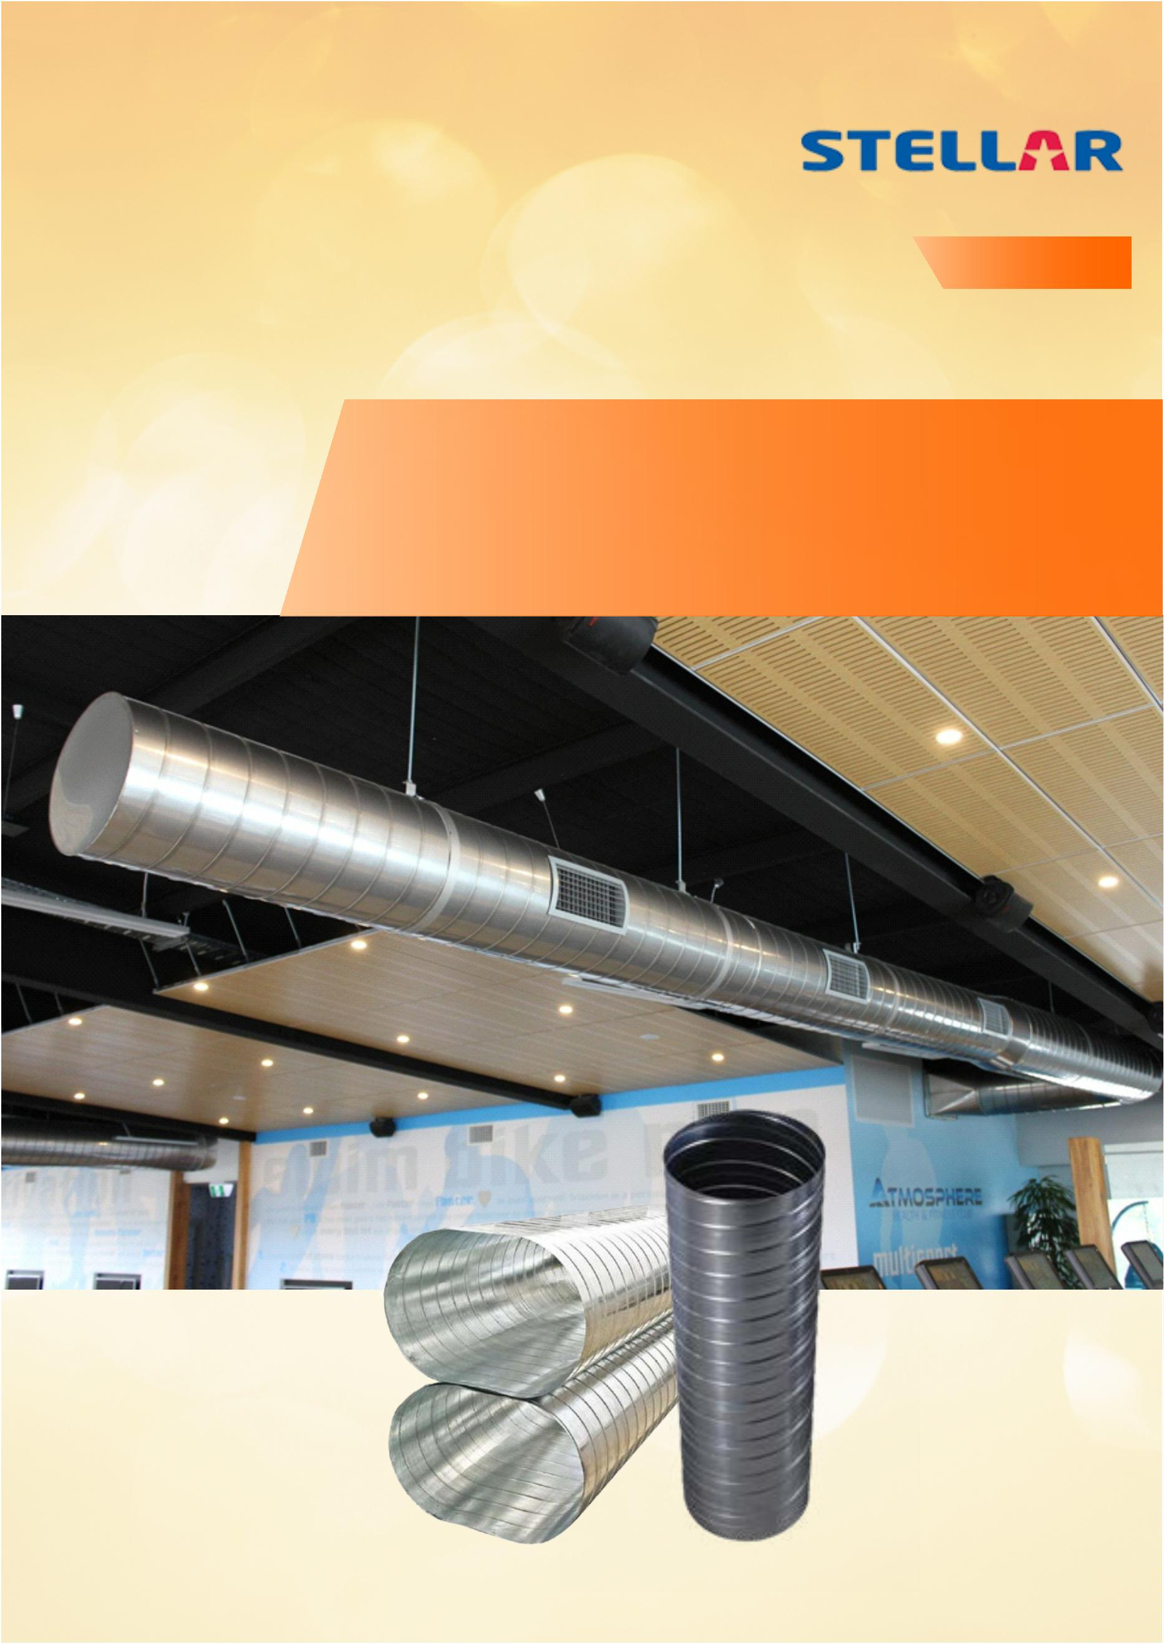

SPIRAL / OVA L DUCT-

FASHIONABLE, EASY TO INSTALL AND ECONOMICAL

Spiral / Oval Duct

Indian duct manufacturing have come a long

Today, more and more companies are

way from hand fabricated duct to factory made switching from rectangular to spiral oval

rigid duct work. This is because

rectangular duct & now Spiral / oval ducts.

Ducts have always been considered an product

which is not esthetically appealing & hence

generally been hidden behind the false sealing.

Now things are changing with spiral/ oval ducts

being aesthetically appealing architects have

started to design the buildings with ceilings

without false panels.

Drivers for Spiral / Oval

Ultra-Low Leakage

Lower Installation Cost

Lesser Space Requirement

Need Less Hangers

Lower Operation Cost

Lesser Noise Level

Easy Cleaning

Weighs Lighter

The big commercial advantage is the perimeter of round ducting system is less by 20% or

more of same cross section of rectangular ducting. The area of ducting and insulation is less by

the same percentage.

Specications

Thickness

Diameter

: 0.50mm (26G) to

.2mm (18G) thickness

1

: Unique any diameter

manufacturing capability

Length

: As per requirement

Material

: Galvanised steel, Aluminum,

Mild steel (CRCA), Stainless

steel.

Surface

Construction

:

Plain or corrugated (to

increase the rigidity of the

ducting)

Manufacturing

standards

: SMACNA, IS & DW.

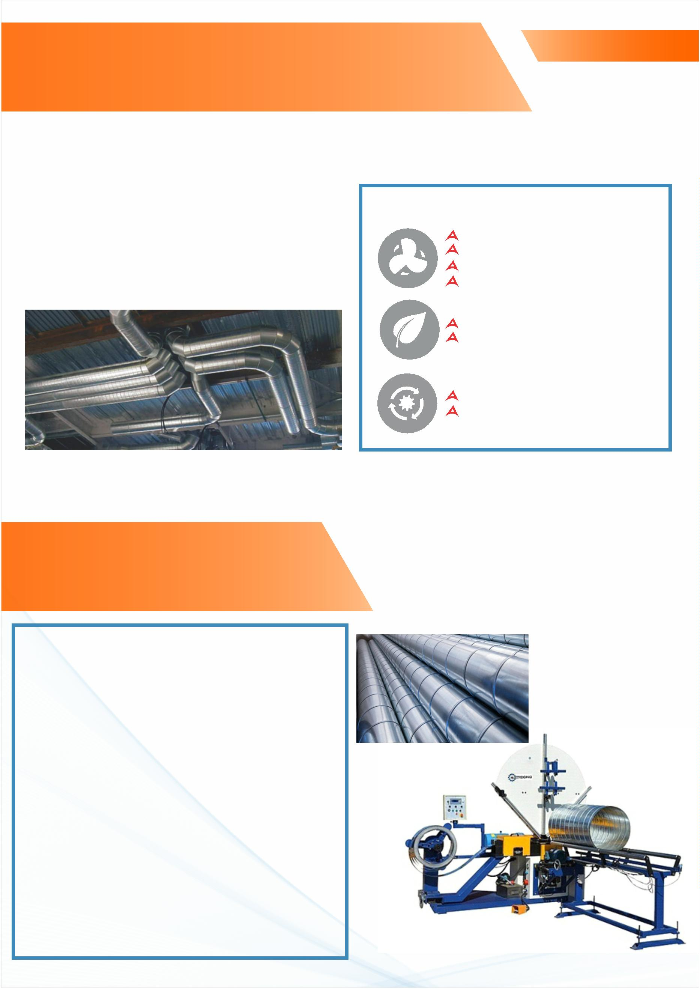

Spiral / Oval Duct

DUCT FITTINGS

Elbow, Reducers, End caps, Offsets etc., with standing seam are manufactured on high accuracy

special purpose machines like CNC Plasma cutter, Gore Locker, Button Locker, Roll Former &

stitch welder.

JOINTING SYSTEM

We offer wide range of joining systems to choose from depending upon cost, performance &

ease of assembly.

Plain Coupling Joint

Coupling Joint With Gasket

–

“STELLAR”

GI Flanged Joint

MS Angle Joint

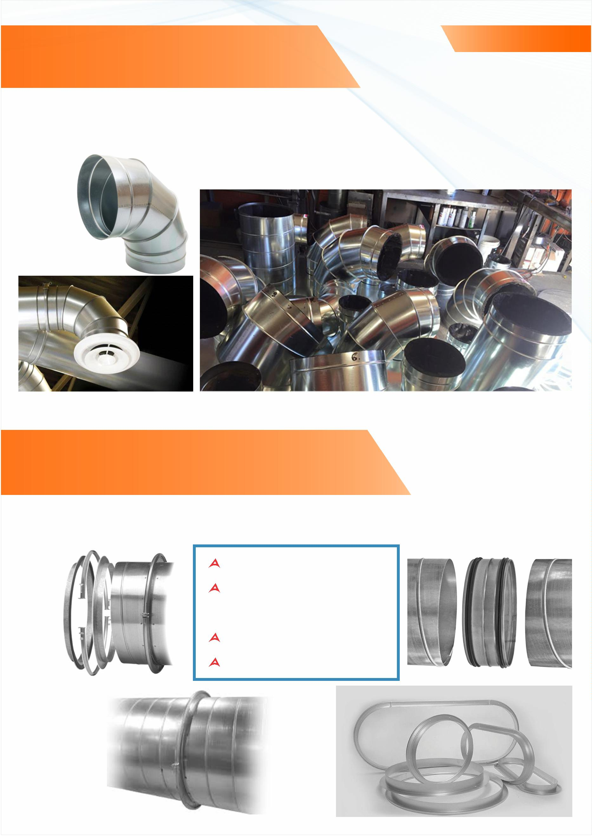

Spiral / Oval Duct

1

. PRE PAINTED DUCT :

3.DOUBLE WALL DUCTS :

Spiral/ oval ducts when exposed (without false STALLER dual wall duct and ttings are

ceiling)

needs to be colour coated to

made with 1” of berglass insulation

compliment with the interior of the building.

Our Duct & Acoustical Products are available

sandwiched between the outer shell and a

solid or perforated inner metal liner. Dual

pre-coated with wide range of colours. We can wall duct is also available in 2”, 3”, and 4”

even provide inner side of the duct painted with thickness. Duel wall ducts are ideal for

special chemicals to for Antimicrobial coating. applications where insulation is needed on the

duct yet the duct needs to be exposed

(without false ceiling). The perforated inner line

is ideal for applications where acoustic

insulation is needed in a spiral/ oval duct.

2

.PRE INSULATED DUCTS : 4. FIRE PAINTED DUCTS :

We also offer ducts with internal or external

insulation like nitrile rubber, glass wool, rock

wool & FRP (for highly corrosive applications).

Fire rated ducts are a must for several

applications & we can provide our ducts

painted with industry's leading re paint

brands. This will not only save time at the job-

site but also ensures better quality controls

due to controlled environment in the factory

as compared to job-sites.

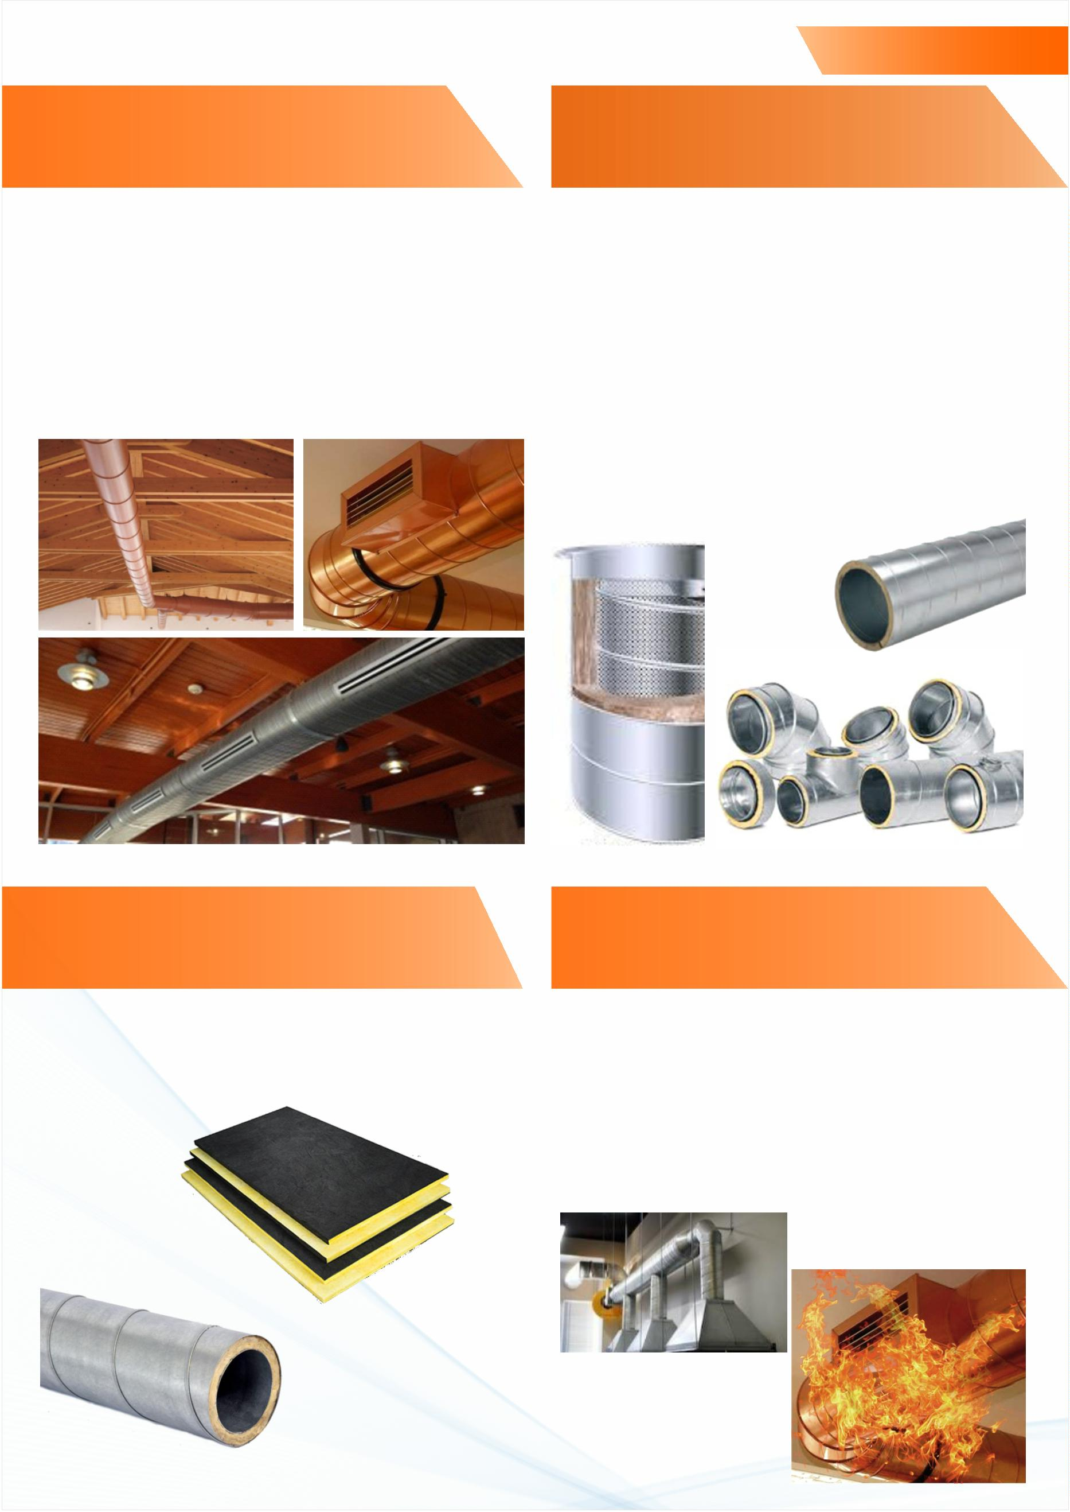

Spiral / Oval Duct

SPIRAL/ F LAT OVAL ACCESSORIES :

TIE RODS :

WALL MOUNT BRACKETS :

We offer few different tie rod options for

you to choose based on cost & convenience

H Frame

Twin H frame

Twin H frame with

hanging bracket

Custom made

based on need

TOP BRACKET HANGING SYSTEM :

FABRICATED BOTTOM SUPPORTS :

WRAP AROUND HANGING STRIP :

ACCESS DOORS :

we can provide few different types of

access doors to choose from.

WIRE - ROPE HANGING SYSTEM :

FLEXIBLE CANVAS CONNECTION :

Insulated exible

canvas connection

Non insulated

